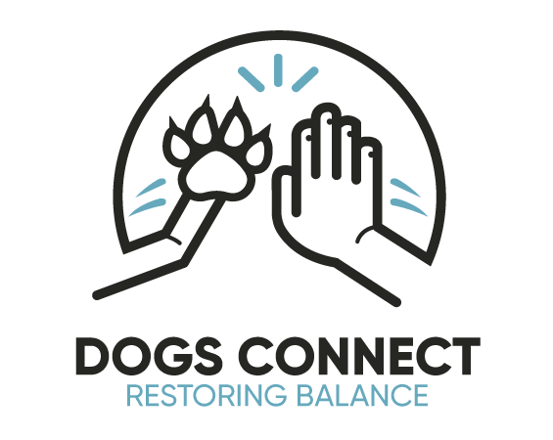

Dogs in Education Agreed Practice

Vision: At Wodonga West Children’s Centre our vision is 'Learning for Living' which underpins all that we set out to achieve in shaping students for their future lives within and beyond schooling.
We strive to:
- Develop lifelong learners who will become active citizens and participate responsibly in community life
- Provide a safe, tolerant and welcoming school environment that encourages personal responsibility and respect for the rights of others.

Introduction:

In alignment with the aims of our Dogs in School Policy, we agree to implement, manage, and evaluate the practices and processes used so that we maintain safe and meaningful interactions between dogs and all other members of our school community. To achieve these standards we have the following agreements and practices in place:

Responsibilities of the School
The school recognises that having a dog is an expensive venture. As a school we are aware that the Dog in School’s program can be run with either a dog owned by a staff member or a dog owned by the school. In the event of the dog being owned by the school the school will take all financial responsibility for the dog and its upkeep/health and registration.

For a dog owned by a staff member, the responsibilities of the school are as follows:
- Ensure that the dog is covered by pet insurance on a yearly basis
- Ensure that the costs of yearly vaccinations are covered
- Provide all equipment needed for the dogs time spent at school including bedding, toys, leads, water bowl. Replacements will be reviewed and provided for (if needed) each year
- Ensure any fixed equipment that is needed in classrooms for the dog are purchased and installed.

Responsibilities of Leadership

The responsibilities of leadership are as follows:
- Ensure that all staff have access to and have had opportunities to read and review related policy
- Ensure communication with broader school community regarding related programs and processes
- Continue to assess, evaluate, and implement actions as recommended through consulting specialists and school community

Responsibilities of Employees

The responsibilities of employees are as follows:

- Become familiar with Dogs in School Policy and Agreed Practice documents
- Become familiar with Risk Assessment document and adhere to related recommendations
- Suggest amendments to above mentioned documents if deemed necessary through observation or reports from students or caregivers
- Become familiar with the International Standards for Animals Assisted Education.
- Always ensure that students are actively supervised when interacting with the dog.
- Demonstrate and explicitly teach safe interaction options to students - this refers to walking on lead, general interactions, and sanitising after handling.
- Always allow time for the dog to wake up, avoid sudden awakening.
- The dog will always be led by attachment to lead when students and/or staff are walking with him/her unless deemed safe and appropriate by staff with responsibility for him/her.
- People move slowly and in a predictable manner when walking with the dog on lead.
- Consider that the dog needs to be in the classrooms and school buildings and make decisions on where the dog can play, roll, run, frolic based on this consideration.
- Be proactive when considering or having awareness of potential hazards or dangers to the dog - make decisions based on the priority being safety for the dog.
- Exercise caution and base decisions about managing the dog during any given scenario on common sense and safety.
- Never allow the dog to ‘feed’ or have bones or similar in classrooms or around students.

Evaluation:
We will monitor the implementation of this Agreed Practice by:
- Re-read annually
- Reviewing in April 2023

