YARD DUTY AND SUPERVISION

POLICY
Purpose
To ensure school staff understand their supervision and yard duty responsibilities.

Scope

This policy applies to all teaching and non-teaching staff at Wodonga West Primary School, including education support staff, casual relief teachers and visiting teachers.

Policy
Appropriate supervision is an important strategy to monitor student behaviour and enables staff to identify and respond to possible risks at school as they arise. It also plays a vital role in helping schools to discharge their duty of care to students.
The Principal is responsible for ensuring that there is a well organised and responsive system of supervision and yard duty in place during school hours, before and after school, and on school excursions and camps and other school activities.
School staff are responsible for following reasonable and lawful instructions from the Principal, including instructions to provide supervision to students at specific dates, times and places.

Before and after school
Wodonga West Primary School’s grounds are supervised by school staff from 8.45 am until 3.45pm. Outside of these hours, school staff will not be available to supervise students. Supervision at these times is limited to two staff and therefore the grassed oval/soccer field areas and blue play equipment are out of bounds. All students are to remain in the grapevine area or under the Gunyah and basketball court including the ‘Red playground’.
Parents and carers will be advised through termly notifications in our school newsletter that they should not allow their children to attend Wodonga West Primary School outside of these hours. Families are encouraged to contact THEIRCARE on 1300 072 410 or refer to https://theircare.com.au/ for more information about the before and after school care facilities available to our school community.
If a student arrives at school before supervision commences at the beginning of the day, the principal or nominee staff member will, as soon as practicable, follow up with the parent/carer to:
- advise of the supervision arrangements before school
- request that the parent/ carer make alternate arrangements.
If a student is not collected before supervision finishes at the end of the day, the principal or nominee staff member will consider whether it is appropriate to:
- attempt to contact the parents/carers
- attempt to contact the emergency contacts
- place the student in an out of school hours care program (if available)
- contact Victoria Police and/or the Department of Health and Human Services (Child Protection) to arrange for the supervision, care and protection of the student.
Yard duty Zones:
The designated yard duty areas for our school from Term 3 2021 – Term 3 2022 are:
Zone | Area
Area 1 | Football Oval
Area 2 | Gunyah / Playground/maths garden
Area 3 | Soccer Oval

Map:
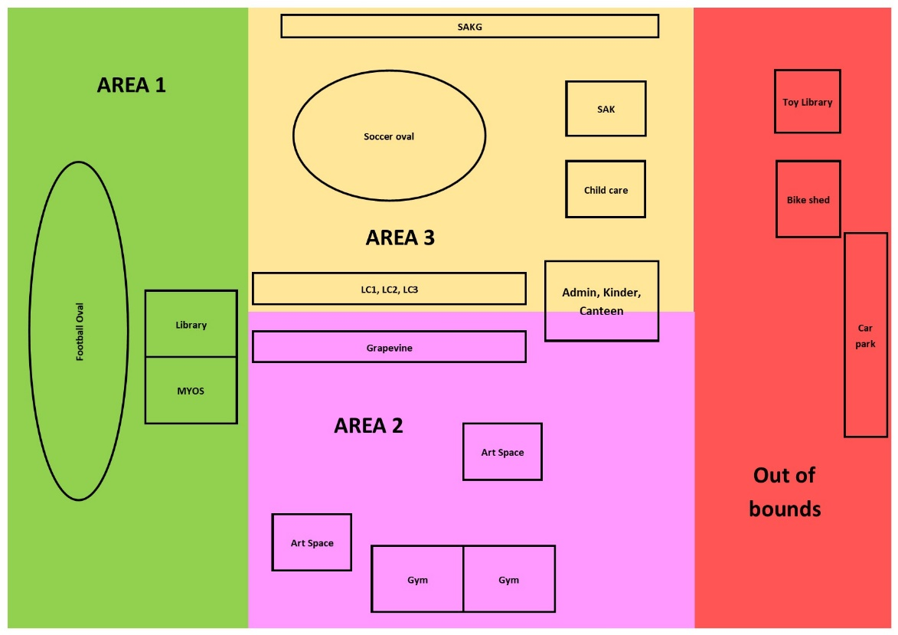
Yard Duty Equipment & Staff Responsibilities:
School staff must wear a provided safety/hi-vis vest whilst on yard duty. Safety/hi-vis vests will be provided and stored in every classroom. Staff must also carry have a bum bag with basic first aid supplies including sick bay passes. It is the staff members’ responsibility to ensure their bum bag supplies are regularly replenished.

Staff who are rostered for yard duty must remain in the designated area until they are replaced by a relieving teacher.
During yard duty, supervising staff must:
- Classroom teachers are responsible for supervising students for the 10 minute eating time at the beginning of lunch and recess
- methodically move around the designated zone
- be alert and vigilant
- intervene immediately if potentially dangerous or inappropriate behaviour is observed in the yard enforce behavioural standards and implement appropriate consequences for breaches of safety rules, in accordance with any relevant disciplinary measures set out in your school’s Student Engagement and Wellbeing policy
- Yard duty staff members are also to have a Duty Clipboard and are required to implement and reward the expectations for yard behaviour with students as per our school wide positive behaviour matrix.
- During Sun-smart times (September to April) staff are expected to wear an appropriate hat and ensure they have applied sun protection if required
- ensure that students who require first aid assistance receive it as soon as practicable
- ensure the yard is left tidy and that any OH&S issues are reported to the OH&S officer/Leadership.
- log any incidents or near misses as appropriate in the yard incidence slips/SWPBS referral form which are then handed into the wellbeing officer.
If the supervising staff member is unable to conduct yard duty at the designated time, they should contact the Principal/ Assistant Principal with as much notice as possible prior to the relevant yard duty shift to ensure that alternative arrangements are made.
If the supervising staff member needs to leave yard duty during the allocated time, they should contact the Principal/ Assistant Principal but should not leave the designated area until the relieving staff member has arrived in the designated area.
If a relieving or next staff member does not arrive for yard duty, the staff member currently on duty should send a message to the office/call Assistant Principal and not leave the designated area until a replacement staff member has arrived.
Should students require assistance during recess or lunchtime, they are encouraged to speak to the supervising yard duty staff member.
If Staff become aware of unknown visitors in the school grounds if safe to do so they should approach and request they leave school grounds. Staff should maintain visual contact whilst they use their mobile phone to seek assistance from the office.

Classroom
The classroom teacher is responsible for the supervision of all students in their care during class. If a child is asked to leave the classroom they will wear the approved lanyard showing they have permission to leave e.g. toilet break or attend the office.
If a teacher needs to leave the classroom unattended at any time during a lesson, they should first contact their team members alongside them or leadership for assistance. The teacher should then wait until a replacement staff member has arrived at the classroom before leaving.

School activities, camps and excursions
The Principal and leadership team are responsible for ensuring that students are appropriately supervised during all school activities, camps and excursions, including when external providers are engaged to conduct part or all of the activity. Appropriate supervision will be planned for school activities, camps and excursions on an individual basis, depending on the activities to be undertaken and the level of potential risk involved.

Digital devices and virtual classroom
Wodonga West Primary School follows the Department’s Cybersafety and Responsible Use of Technologies Policy with respect to supervision of students using digital devices.
Wodonga West Primary School will also ensure appropriate supervision of students participating in remote and flexible learning environments while on school site. In these cases, students will be supervised from the resource centre or in the case of high numbers from a set classroom in each unit across the school.

While parents are responsible for the appropriate supervision of students accessing virtual classrooms from home:
- student attendance will be monitored using Class Dojo and attendance during daily Class Webex meetings
- any wellbeing or safety concerns for the student will be managed in accordance with our usual processes – refer to our Student Wellbeing and Engagement Policy and our Child Safety Responding and Reporting Policy and Procedures for further information.

Students requiring additional supervision support
Sometimes students will require additional supervision, such as students with disability or other additional needs. In these cases, the Principal or delegate will ensure arrangements are made to roster additional staff as required. This may include on yard duty, in the classroom or during school activities.

Supervision of student in emergency operating environments
In emergency circumstances our school will follow our Emergency Management Plan, including with respect to supervision.
In the event of any mandatory period of remote or flexible learning our School will follow the operations guidance issued by the Department.
COMMUNICATION

This policy will be communicated to our school community in the following ways

- Included in staff induction processes /folder
- Discussed at staff briefings or meetings, as required
- Included as a termly update in our school newsletter each term.
- Made available in hard copy from school administration

Information for parents and students on supervision before and after school is available on our school website and parent reminders are sent at the beginning of each term in our school newsletter.

Further Information and Resources
- the Department’s Policy and Advisory Library (PAL):
  - Child Safe Standards
  - Cybersafety and Responsible Use of Technologies
  - Duty of Care
  - Excursions
  - Supervision of Students
  - Visitors in Schools

POLICY REVIEW AND APPROVAL

Policy last reviewed | September 2021
Approved by | School Council September 2021
Next scheduled review date | September 2022

This policy will also be updated if significant changes are made to school grounds that require a revision of Wodonga West Primary School’s yard duty and supervision arrangements.

