YARD DUTY AND SUPERVISION POLICY

PRIMARY SCHOOL STAFF

Purpose
To ensure school staff understand their supervision and yard duty responsibilities.

Scope
The principal is responsible for ensuring that there is a well-organised and responsive system of supervision in place during school hours, before and after school, and on school excursions and camps.
This policy applies to all teaching and non-teaching staff at Wodonga West Primary School, including education support staff, casual relief teachers and visiting teachers.
School staff are responsible for following reasonable and lawful instructions from the principal, including instructions to provide supervision to students at specific dates, time and places.

Policy

Before and after school
Wodonga West Primary School’s grounds are supervised by school staff from 8.50am until 3.45pm. Outside of these hours, school staff will not be available to supervise students. Supervision at these times is limited to two staff and therefore the grassed oval/soccer field areas and blue play equipment are out of bounds
Parents and carers should not allow their children to attend Wodonga West Primary School outside of these hours. Families are encouraged to contact THEIRCARE on 1300 072 410 or refer to https://theircare.com.au/ for more information about the before and after school care facilities available to our school community.
If a student arrives at school before supervision commences at the beginning of the day, the principal or nominee staff member will, as soon as practicable, follow up with the parent/carer to:
- advise of the supervision arrangements before school
- request that the parent/ carer make alternate arrangements.
If a student is not collected before supervision finishes at the end of the day, the principal or nominee staff member will consider whether it is appropriate to:
- attempt to contact the parents/carers
- attempt to contact the emergency contacts
- place the student in an out of school hours care program (if available)
- contact Victoria Police and/or the Department of Health and Human Services (Child Protection) to arrange for the supervision, care and protection of the student.

School staff who are rostered on for before or after school supervision must follow the processes outlined below.

Yard duty
All staff at Wodonga West Primary School are expected to assist with yard duty supervision and will be included in the weekly roster.
The principal or Assistant Principal is responsible for preparing and communicating the yard duty roster on a regular basis. At Wodonga West Primary School, school staff will be designated a specific yard duty area to supervise. They are also responsible for devising the Wet/Hot Day duty roster and coordinating the Bin Roster. (see Timetable Policy) Staff members will be given the opportunity to have input into the timetables
The yard supervision roster will require staff members to undertake yard duty before school, for lunchtime or recess (but not on the same day), or after school on specific days

The designated yard duty areas for our school as of January 2020 are [outline areas and include map of zones where appropriate i.e:]
Zone | Area
Area 1 | Football Oval
Area 2 | Gunyah / Playground/maths garden
Area 3 | Soccer Oval
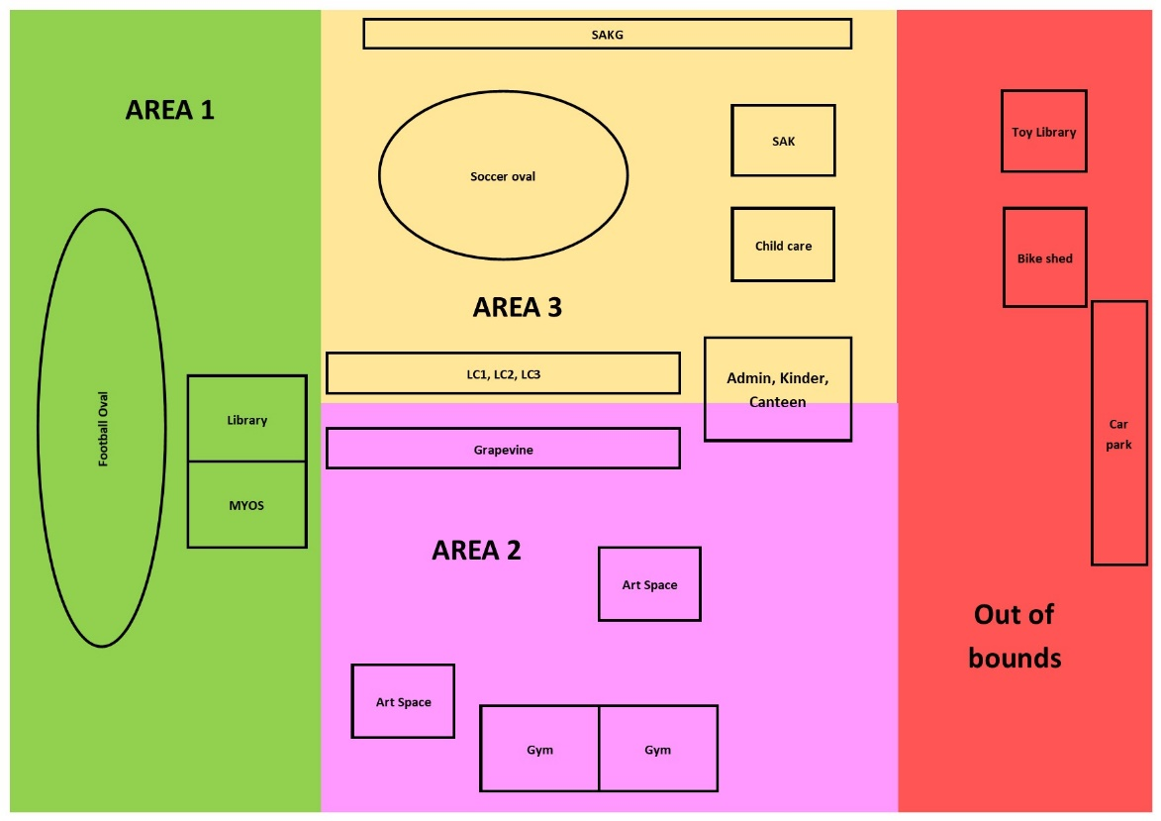
School staff must wear a provided safety/hi-vis vest whilst on yard duty. Safety/hi-vis vests will be provided and stored in every classroom. Staff must also carry have a bum bag with basic first aid supplies including sick bay passes. It is the staff members’ responsibility to ensure their bum bag supplies are regularly replenished.

Staff who are rostered for yard duty must remain in the designated area until they are replaced by a relieving teacher.
During yard duty, supervising staff must:
- Classroom teachers are responsible for supervising students for the 10 minute eating time at the beginning of lunch and recess
- methodically move around the designated zone
- be alert and vigilant
- intervene immediately if potentially dangerous or inappropriate behaviour is observed in the yard enforce behavioural standards and implement appropriate consequences for breaches of safety rules, in accordance with any relevant disciplinary measures set out in your school’s Student Engagement and Wellbeing policy
- Yard duty staff members are also to have a Duty Clipboard and are required to implement and reward the expectations for yard behaviour with students as per our school wide positive behaviour matrix.
- During Sun-smart times (September to April) staff are expected to wear an appropriate hat and ensure they have applied sun protection if required
- ensure that students who require first aid assistance receive it as soon as practicable
- ensure the yard is left tidy and that any OH&S issues are reported to the OH&S officer/Leadership.
- log any incidents or near misses as appropriate in the yard incidence slips/SWPBS referral form which are then handed into the wellbeing officer.
If the supervising staff member is unable to conduct yard duty at the designated time, they should contact the Principal/ Assistant Principal with as much notice as possible prior to the relevant yard duty shift to ensure that alternative arrangements are made.
If the supervising staff member needs to leave yard duty during the allocated time, they should contact the Principal/ Assistant Principal but should not leave the designated area until the relieving staff member has arrived in the designated area.
If a relieving or next staff member does not arrive for yard duty, the staff member currently on duty should send a message to the office/call Assistant Principal and not leave the designated area until a replacement staff member has arrived.
Should students require assistance during recess or lunchtime, they are encouraged to speak to the supervising yard duty staff member.
If Staff become aware of unknown visitors in the school grounds if safe to do so they should approach and request they leave school grounds. Staff should maintain visual contact whilst they use their mobile phone to seek assistance from the office.

Classroom
The classroom teacher is responsible for the supervision of all students in their care during class.
If a teacher needs to leave the classroom unattended at any time during a lesson, they should first contact front office for assistance. The teacher should then wait until another staff member has arrived at the classroom to supervise the class prior to leaving.

School activities, camps and excursions
The principal and leadership team are responsible for ensuring that students are appropriately supervised during all school activities, camps and excursions, including when external providers are engaged to conduct part or all of the activities. Appropriate supervision will be planned for special school activities, camps and excursions on an individual basis, depending on the activities to be undertaken and the level of potential risk involved.

Further Information and Resources
- the Department’s Policy and Advisory Library:
  - Supervision of Students
  - Duty of Care
  - Child Safe Standards
  - Visitors in Schools

Review Cycle
This policy was last updated in August 2020 and is scheduled for review on 2021. This policy will also be updated if significant changes are made to school grounds that require a revision of Wodonga West Primary School’s Yard Duty and Supervision Policy.

