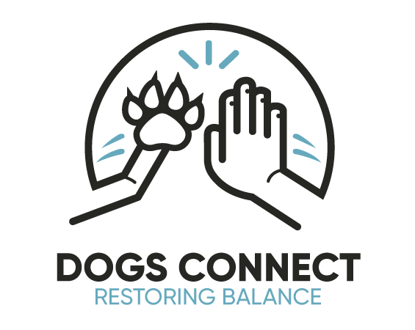

Dogs in Education Policy

Rationale:
At Wodonga West Children’s Centre our vision is 'Learning for Living' which underpins all that we set out to achieve in shaping students for their future lives within and beyond schooling.

Vision:
At Wodonga West Children’s Centre we:
* develop lifelong learners who will become active citizens and participate responsibly in community life.
* provide a safe, tolerant and welcoming school environment that encourages personal responsibility and respect for the rights of others

Beliefs:
At Wodonga West Children’s Centre our values drive us to:
- Have a duty to develop and model practices where teaching and learning can be linked to the love, care, and connection of our school dog.
- Draw on the skills and knowledge of the school, Dogs Connect staff, and the wider community and enter into practices that are mutually beneficial to all community members.
- Implement effective decision-making practices in collaboration with the School Executive, Dogs Connect staff, school staff and where appropriate the wider community.

Aim:
- We aim for the responsible implementation of a structured program through which a school wellbeing dog/s will be used to assist the school community in experiencing connectedness, developing links to learning throughout the school community, and helping to develop students who are socially adept, respectful, just, and appreciative of diversity.

Practices:
This vision is enacted through the following procedures/systems:
- Reflection on current teaching and learning practices and student data.
- A thoroughly considered and gradually implemented program involving the school dog interacting with staff and students on many levels.
- Documentation and review of current risk assessment, agreed practice, and implementation schedule.
- Alignment of Agreed Practice with current pedagogy and student/staff needs.
- Reflection and evaluation to guide future action/implementation to ensure suitability of all practices.
- Clearly signed notification that dogs are not allowed on school grounds, unless previously authorised.

Evaluation:
We will monitor the implementation of this Policy by:

Reviewed by School Council In April 2021 and will be reviewed in April 2023

